
Student Performance Data Analysis



1. Introduction
This project analyzes student academic performance using Microsoft Excel. The purpose of the project is to identify performance patterns, analyze attendance and marks, and present useful information through tables, charts and a dashboard.

2. Problem Statement
Educational institutions collect a large amount of student information, but raw data is difficult to understand without proper analysis. Therefore, this project aims to analyze student performance data and present meaningful insights that can support academic decision-making.

3. Objectives
- Analyze student academic performance.
- Calculate average and overall marks.
- Analyze student attendance.
- Compare performance between genders.
- Identify different performance levels.
- Create a dashboard to present the results.

4. Dataset
The dataset contains information about 30 students, including gender, age, attendance, assignment marks, examination marks and final marks.
5. Tools Used
- Microsoft Excel
- PivotTables
- Excel formulas
- Excel charts
- Excel dashboard
6. Data Analysis
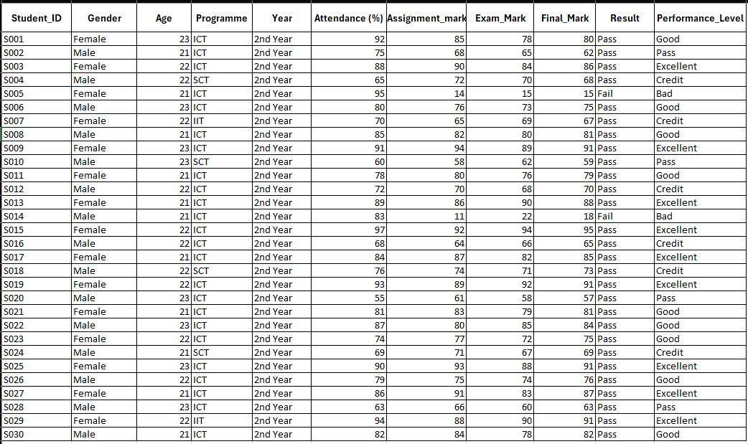
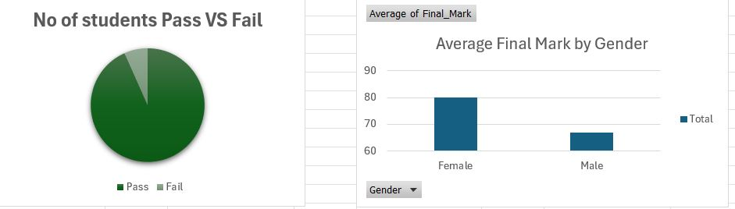
In this project, Microsoft Excel was used to analyse student performance data. The dataset contains information about 30 students, including attendance percentage, assignment marks, examination marks, final marks, and pass/fail results.

6.1 Calculations
Several Excel formulas were used to summarize the student data and understand overall academic performance.
1. Total Number of Students
The COUNTA() function was used to calculate the total number of students in the dataset.
Formula: =COUNTA(Student_Data!A2:A31)
This calculation identifies the number of student records included in the analysis.
2. Average Final Mark
The AVERAGE() function was used to calculate the average final mark of all students.
Formula: =AVERAGE(Student_Data!I2:I31)
This calculation helps to understand the overall academic performance of the students.

3. Highest Final Mark
The MAX() function was used to identify the highest final mark obtained by a student.
Formula: =MAX(Student_Data!I2:I31)
This helps identify the best performance in the dataset.

4. Lowest Final Mark
The MIN() function was used to identify the lowest final mark.
Formula: =MIN(Student_Data!I2:I31)
This helps identify the lowest performance in the dataset.

5. Number of Students Who Passed
The COUNTIF() function was used to count the number of students who passed.
Formula: =COUNTIF(Student_Data!J2:J31,"Pass")
In this dataset, a student is classified as having passed when the final mark is 50 or above.

6. Pass Percentage
The pass percentage was calculated by dividing the number of students who passed by the total number of students.
Formula: =COUNTIF(Student_Data!J2:J31,"Pass")/COUNTA(Student_Data!A2:A31)
The result was formatted as a percentage in Excel. This calculation shows the proportion of students who passed.

7. Average Attendance
The AVERAGE() function was used to calculate the average attendance percentage.
Formula: =AVERAGE(Student_Data!F2:F31)
This helps examine the overall attendance level of the students.

6.2 PivotTable Analysis
An Excel PivotTable was used to compare student performance by gender. The Gender field was placed in the Axis (Categories) area, while Final_Mark was placed in the Values area. The Values calculation was changed from Sum to Average to calculate the average final mark for each gender. The summarized results were presented using a column chart titled “Average Final Mark by Gender.” This visualization helps compare the average marks of male and female students in the dataset.
6.3 Data Visualization
Charts were used to present the analysis results clearly. A pie chart was used to display the number of students who passed and failed, while a column chart was used to compare average final marks across programmes.
These visualizations help users identify overall performance patterns and understand the results more easily.

- Dashboard
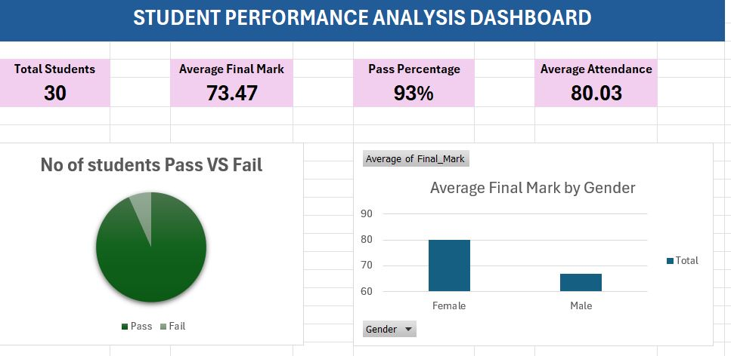
This dashboard shows how 30 students performed in their exams.
The students did well overall. The average final mark is about 73 out of 100, and 93% of them passed, so only 2 students failed. They also attended class regularly, about 80% of the time on average.
The bar chart now shows the average final mark for the ICT programme, which is about 73. This matches the average final mark at the top, so the numbers agree with each other.

8. Findings
The analysis of the 30-student dataset produced the following findings:
- Overall Performance: The average final mark was 73.47 out of 100.
- Highest and Lowest Marks: The highest final mark was 95, while the lowest was 15.
- Pass Rate: Out of 30 students, 28 passed and 2 failed. The pass percentage was 93.33%.
- Attendance: The average student attendance was approximately 80.03%.
- Performance by Gender: The average final mark was approximately 80.13 for female students and 66.80 for male students in this dataset.
- Data Visualization: The dashboard presents the key performance indicators and charts, making the results easier to understand.
These findings summarize the academic performance and attendance patterns in the dataset. The gender comparison describes this dataset only and does not establish that gender causes differences in academic performance.

9. Summary
This project focused on analysing student performance data using Microsoft Excel. Several Excel functions, including COUNTA, AVERAGE, MAX, MIN, and COUNTIF, were used to calculate important performance indicators. A PivotTable was created to compare average final marks across programmes, and charts were used to present the results visually.
The analysis was organized into a dashboard containing key performance indicators and charts. This dashboard provides a clear and convenient way to understand student performance without examining the entire dataset.
Through this project, practical skills in data cleaning, data analysis, Excel formulas, PivotTables, data visualization, and dashboard development were developed. The project also demonstrated how raw data can be transformed into meaningful information to support better understanding and decision-making.

